Francotyp-Postalia - ‘Mymail’: FM2500001 to FM2500999

This series was first introduced in March 2004.

16 images

The FM series is uncommon and scans of other examples would be appreciated.


FM2500071
BIDEFORD
E14.04.04
User: Cowling Levick – Estate Agents
Thematics: None
Notes: None

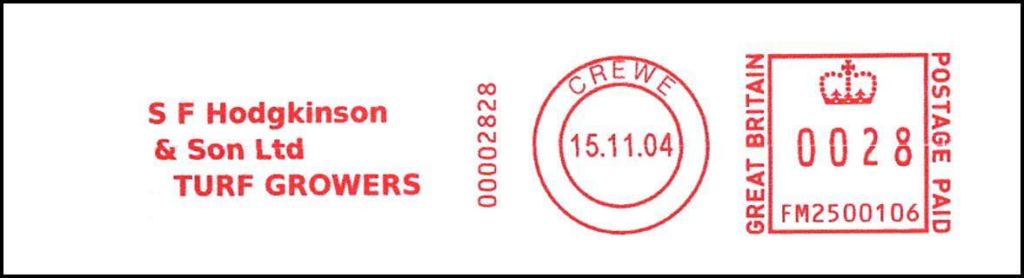
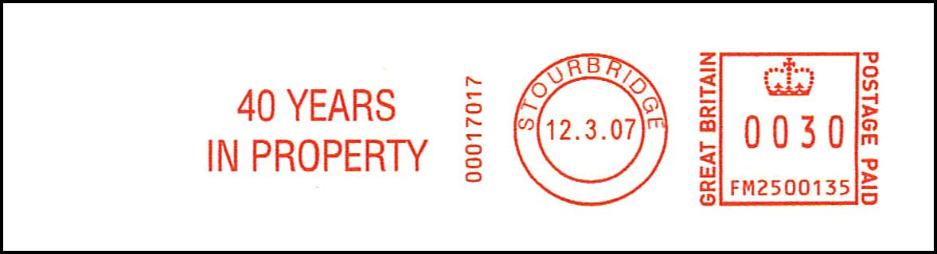
FM2500135
STOURBRIDGE
E12.03.07
User: Lee, Shaw – Chartered Surveyors
Thematics: None
Notes: None

PM 01.03.08

FM2500175
WATFORD
E01.04.05
User: Railway Heritage Trust
Thematics: Railways
Notes: None

FM2500200
BIRMINGHAM
E19.01.06
User: Acorns Children’s Hospice
Thematics: Flora, Children
Notes: None

FM2500223
ROCHDALE
E22.10.04
User: Deckers
Thematics: None
Notes: None

FM2500337
STOURBRIDGE
E12.04.07
User: Unknown
Thematics: None
Notes: None

FM2500406
HITCHIN
E25.08.05
User: Academy Design
Thematics: None
Notes: None

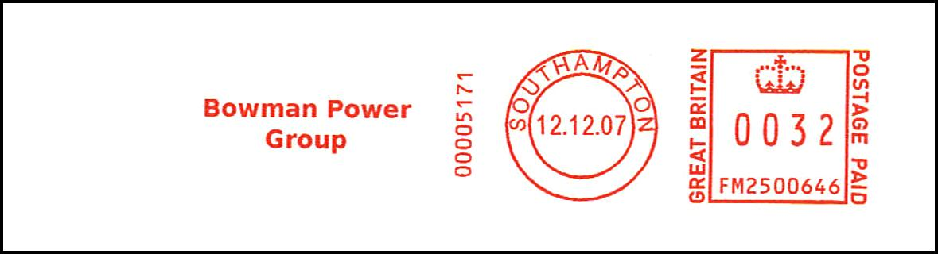
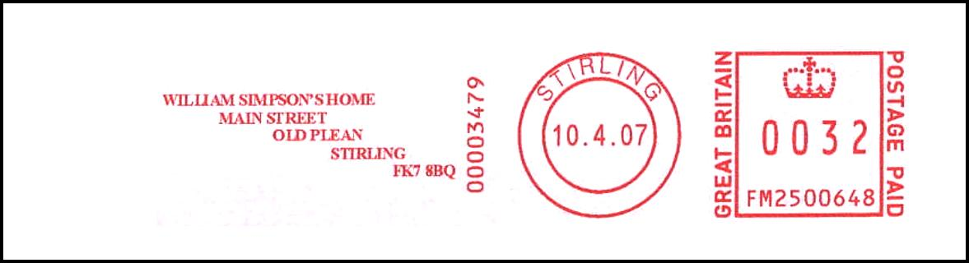

FM2500842
BIRMINGHAM
E19.08.05
User: Unitemps
Thematics: None
Notes: None

FM2500883
BIRMINGHAM
E09.05.05
User: Cornerstone
Thematics: Flora
Notes: None

FM2500992
BIRMINGHAM
E08.09.05, L31.11.06
User: Unknown
Thematics: None
Notes: None

